BS1220

3.13: Worksheet 3

1. Complete the worksheet questions which were included within the timetabled sessions
2. Adapt your answers to the worksheet to have appropriate parameters for your functions
3. Adapt your sayHelloWorld() function so that it takes a name as a parameter and outputs the following (where “Alice” was passed to the function as an argument):

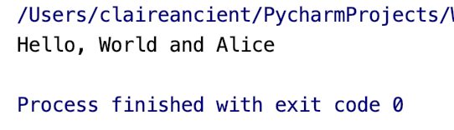

Ans:

user_name = "Alice"  
def say_hello_world(name):  
 print("Hello, World! and " + name)  
say_hello_world(user_name)

1. Write a function (called printAverage) which takes four numbers as the parameters and calculates their average. The average should be printed to 3 decimal places.

Ans:

def printAverage(a, b, c, d):  
 total = a + b + c + d  
 average = float("{0:.3f}".format(total/4))  
 print(average)  
  
printAverage(20.3, 5.87, 40.2, 2)

1. Enter the following function within your Python file:

def getNumber():

enteredNumber = float(input("Please enter a number: "))

return enteredNumber

* 1. Before you run your function, what do you think it does?

Ans:

It is asking the function to return the user input.

* 1. Adapt your main method so that the function runs

Ans:

def getNumber():  
 enteredNumber = float(input("Please enter a number: "))  
 return enteredNumber  
  
a = getNumber()  
print(a)

1. Using both the getNumber() and printAverage() functions, write a function (called getAverage()) which will take in 4 numbers entered by the user and output their average.

Ans:

*def getAverage():  
 num1 = getNumber()  
 num2 = getNumber()  
 num3 = getNumber()  
 num4 = getNumber()  
 printAverage(num1, num2, num3,num4)  
  
getAverage()*

1. Write a function (called happy_birthday) which takes 2 parameters (name and age) and prints a birthday message to the person whose name and age has been passed. The printed message must include the name and age of the person you are wishing happy birthday to.
   1. Set the age to have an appropriate default parameter

Ans:

def happy_birthday(name, age = 38):  
 print("happy_birthday ", name)  
 print("You are ", age)  
  
happy_birthday(name = "Jack", age = 38)

* 1. Test your program to verify that the default parameter is used when no argument is passed for age

Ans:

def happy_birthday(name, age = 38):  
 print("happy_birthday ", name)  
 print("You are ", age)  
happy_birthday(name = "Jack")

code still returns: happy_birthday Jack

You are 38

* 1. Use the following statements to run your program:

happy_birthday(age = 12, name = “Alice”)

happy_birthday(name = “Alice”, age = 12)

What is happening when you use this command?

Ans:

def happy_birthday(name, age = 12):  
 print("happy_birthday ", name)  
 print("You are ", age)  
  
happy_birthday(name = "Alice", age = 12)  
happy_birthday(age = 12, name = "Alice")

code returns: happy_birthday Alice

You are 12

happy_birthday Alice

You are 12

* 1. What is the correct terminology for this use of arguments and parameters?

Ans: Anonymous Function

1. Write a function which allows the user to enter 5 names, which are then stored within a list. Then, using your sayHelloWorld(name) function, say hello to the first and last name in the list. For example:

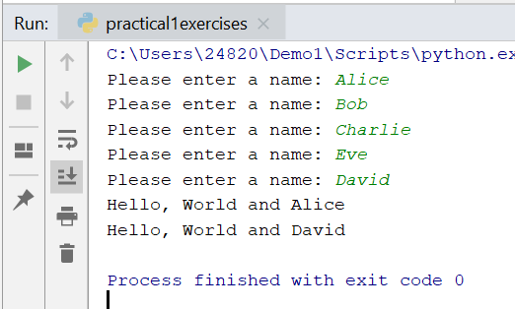

1. Write a series of functions which takes the radius of a circle and outputs the following information: diameter, circumference, and area. The output should be as follows:

*Hint 1: you will need to have 4 functions*

*Hint 2: you will need to put the following code at the top of your file:*

import math

*This will import the math module, which will give you access to the pi variable. This is the documentation for the module:* <https://docs.python.org/2/library/math.html>